BLOGPOST - 10 Essential Links For Testing Your Value Proposition & Business Models

Business experiments and tests are important procedures for validating, invalidating, and producing evidence for your value proposition or business model hypotheses. But what makes a good business test? How do you know if you are successful or not? In this post, we’ve collected 10 essential links to help you design, implement, and manage your portfolio of experiments.

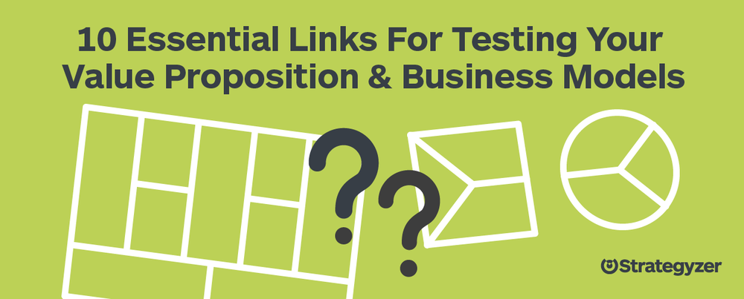

Whether you’re new to testing or need a refresh on designing, implementing and managing your business tests, we’ve made sure to include all the essential links for you in one handy post.

Before You Start Testing

Search = Design, Test, Learn & Iterate
You’ve just kicked off your “search”: the journey that consists of designing and testing business models in rapid iterations to see if your idea can succeed. This is the one of the most difficult tasks as an innovator, entrepreneur and intrapreneur. Read on to learn what you need to pay attention to during this phase to avoid failure.

Roadmap To Test Your Value Proposition
Many entrepreneurs and intrapreneurs struggle with the question of what to test and in which order to test. In this post we show you a roadmap of how to test your value proposition in three steps.

How Card Sorting Can Help You Understand User Priorities
Before you design a solution or even develop the features of your value proposition, you’ll first want to make sure you understand what matters most to your customers. What are the potential jobs, pains, and gains they experience and in what order will you address those customer needs? In this post, we explain how a simple card sorting exercise can help you understand your customers' priorities.
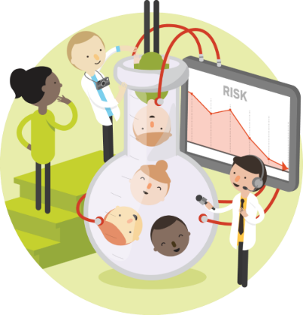

Designing Your Experiments

Don’t Build When You ‘Build-Measure-Learn’
Did you know that you can test many of your business assumptions without even building anything? Entrepreneurs and intrapreneurs often start building early versions of their products and services way too soon. The goal early on is to create the most learning as quickly and efficiently as possible. In this post we explain how to correctly build "Minimum Viable Products" (MVPs) so that you can maximize learning before even building your product or service.

13 Traps That Can Render Your Market Research Irrelevant
Poorly designed experiments can not only render your market research irrelevant, it can also generate an inaccurate picture of how your customers actually behave. Here are 13 traps to avoid when trying to validate or invalidate your business assumptions.

Validate Your Ideas With The Test Card
We created the Test Card so the team at Strategyzer could design and record better experiments and tests. In this post, we explain how it works. Download the Test Card for yourself and try it out. It’s free!

What Do Customers Want?
Co-creating experiments and tests with your customers is a great way to involve them in the process of prioritizing the products, services and features that they will find most valuable. In this post we share two exercises that can integrate your customers into the discovery process.

4 Simple Steps To Build Better Value Propositions With A/B Testing
A/B testing is a popular technique used by product managers and entrepreneurs to validate or invalidate experiments. A slight tweak in copy or imagery on a landing page can make a significant impact on the types of actions your customers perform. In this post we offer a basic primer on A/B testing and share 4 tips on how they can be performed.

Managing Your Tests

Capture Customer Insights & Actions With The Learning Card
It’s pointless to conduct experiments and test your ideas if you don’t learn from them and act upon the obtained insights. That’s why Strategyzer invented the Learning Card: to systematically capture your learnings and make the resulting decisions and actions explicit. Watch the video in this post to discover the Strategyzer Learning Card.

From Idea To Business With Lean Startup & The Progress Board
To help manage the whole testing process, we invented TheProgress Board to monitor your progress by tracking all of your hypotheses, Test Cards, and Learning Cards in one tool. In this post we show you how it works. You can also download The Progress Board for free.

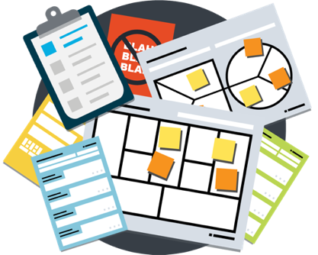

Aus <http://blog.strategyzer.com/posts/2015/12/17/10-essential-links-for-testing-your-value-proposition-business-models>

